How to Download Jabber on an Android

To utilize Jabber on your Android to both make and receive calls and chats, configurations changes are first needed. Please submit a HelpDesk ticket yourself, select “Cisco Jabber Softphone” and read the 911 terms. In the request detail specify whether you will be using an iPhone or Android.

- Click on the Google Play Store icon.
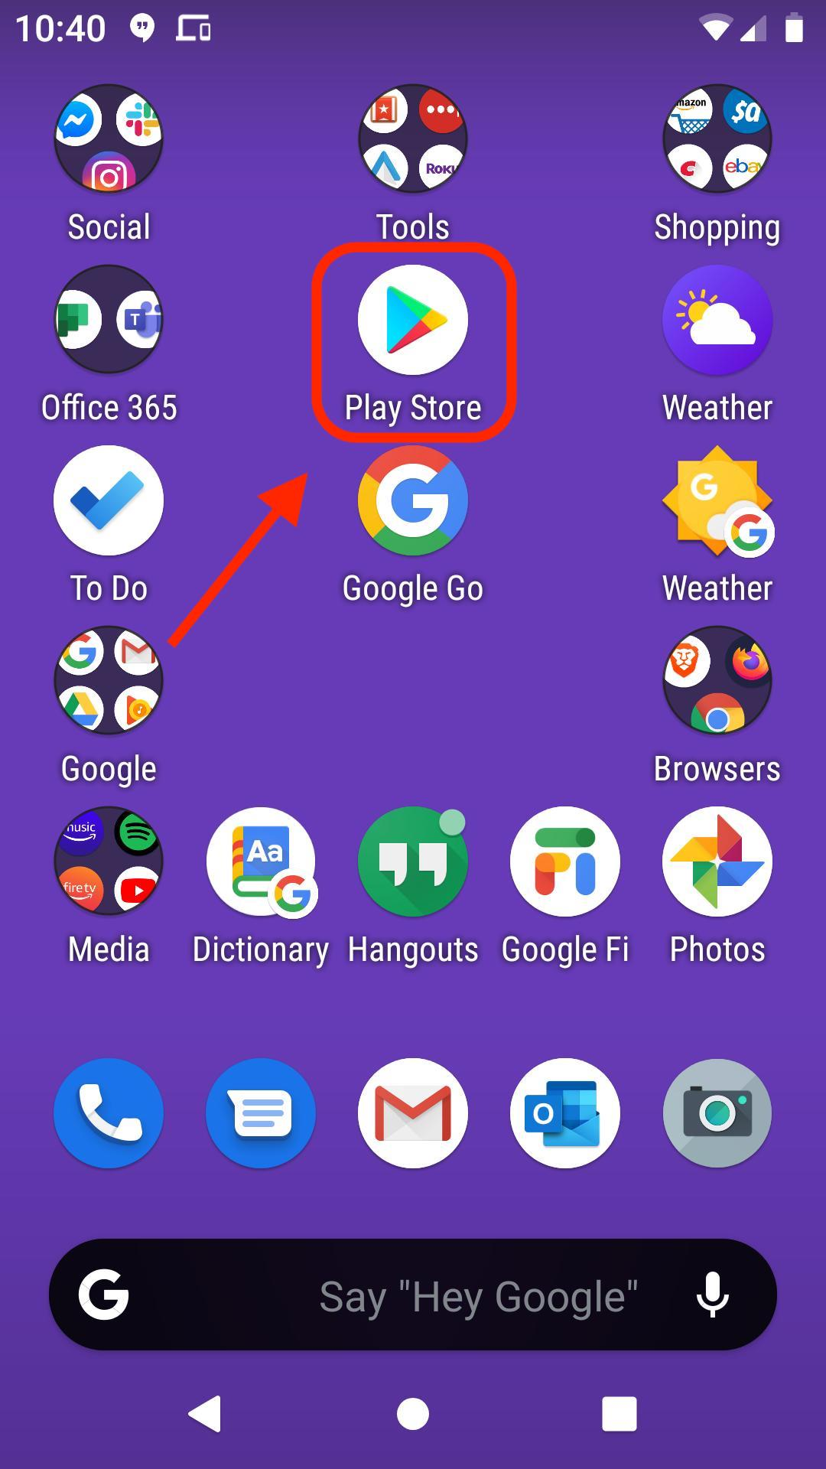

- Click the “Apps” icon at the bottom then click the Search bar at the top.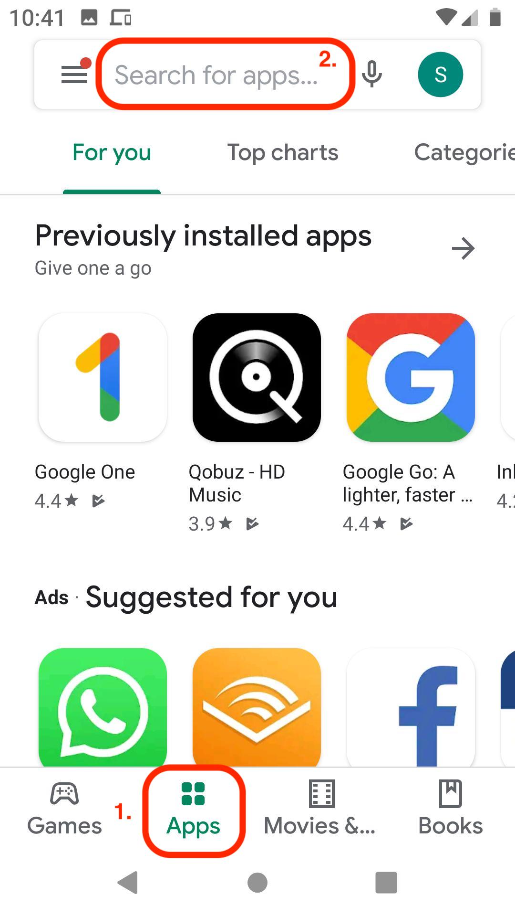

- Type “Cisco Jabber” into the search bar then click the search button.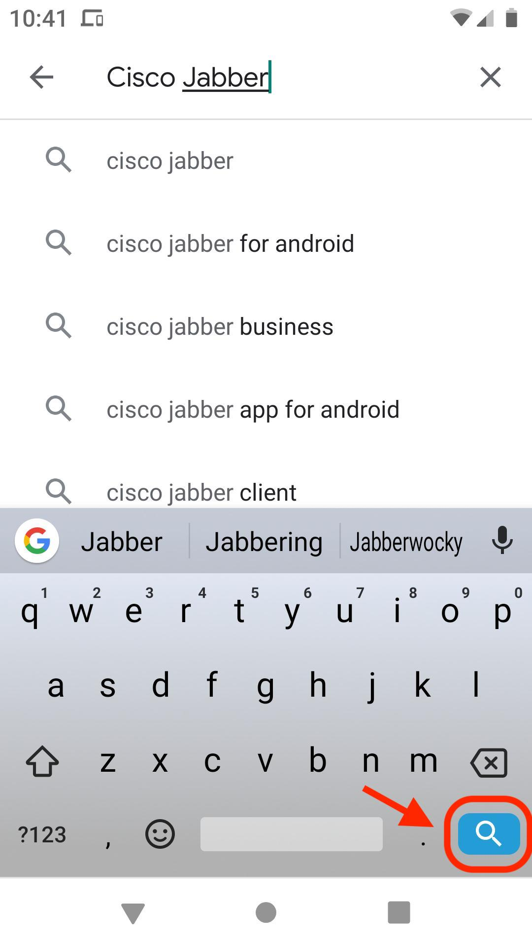

- Select the “Install” button
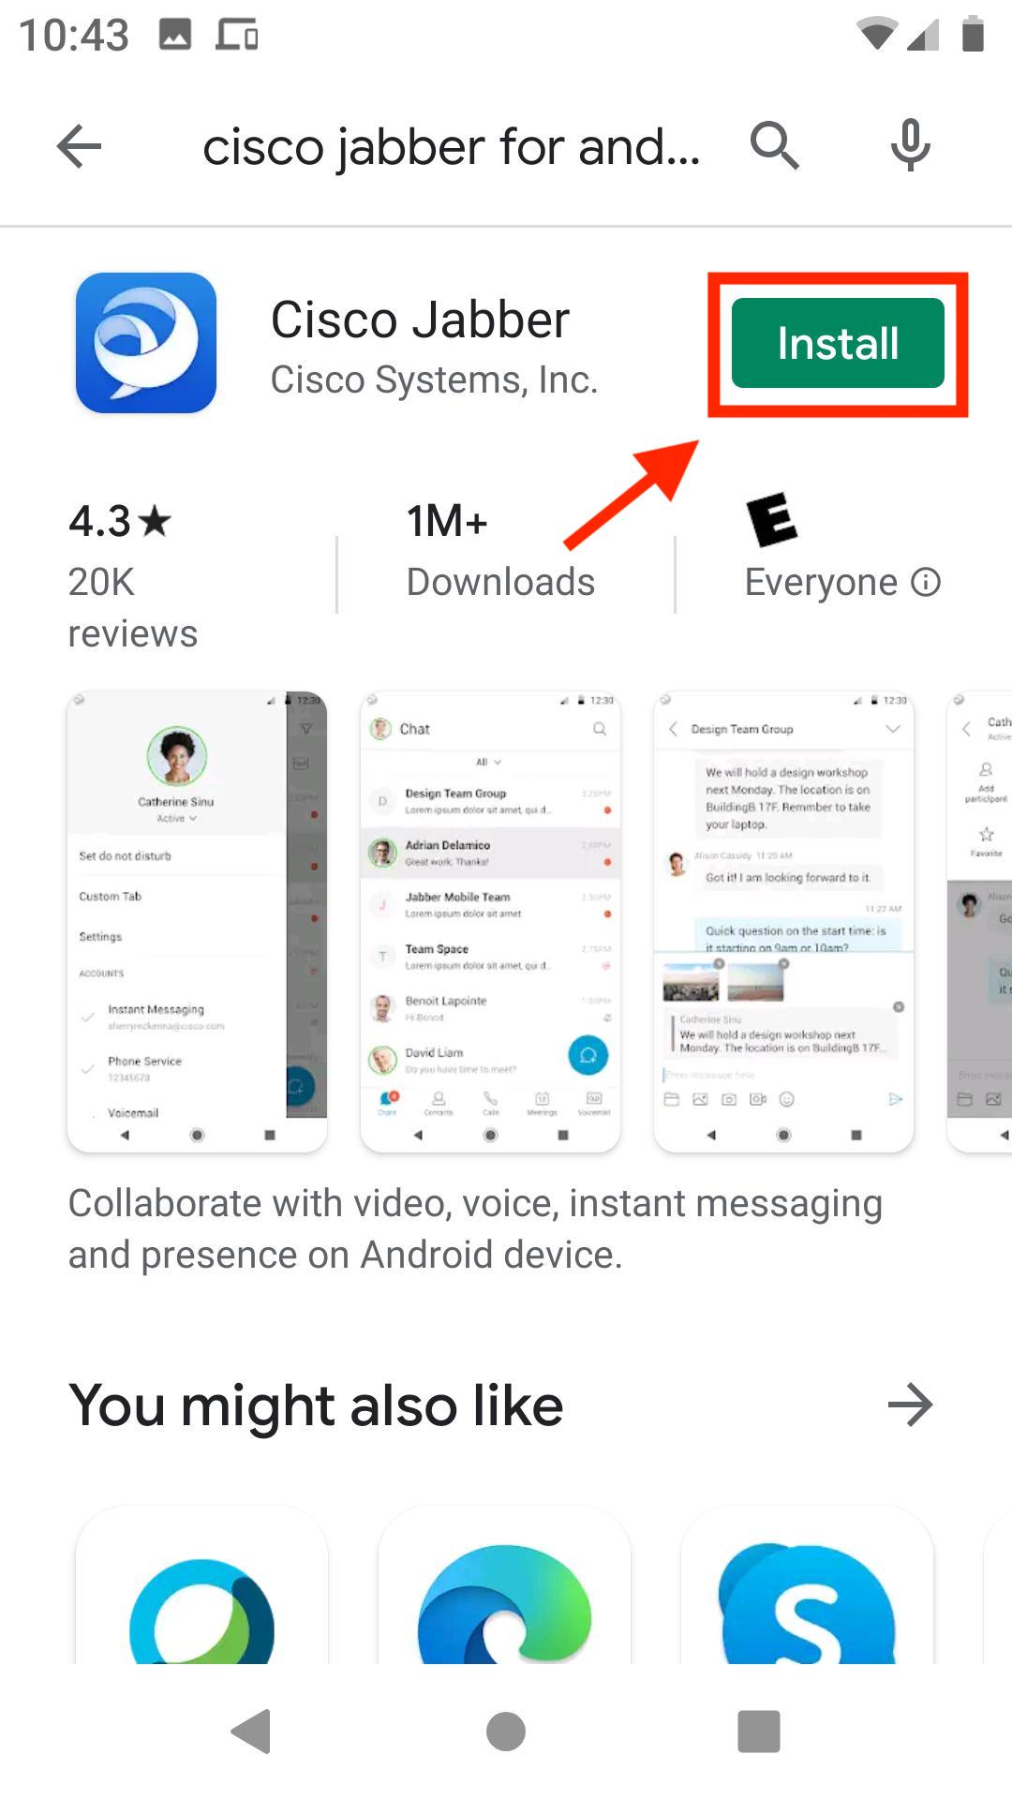

- Select “Open” once app has finished downloading.
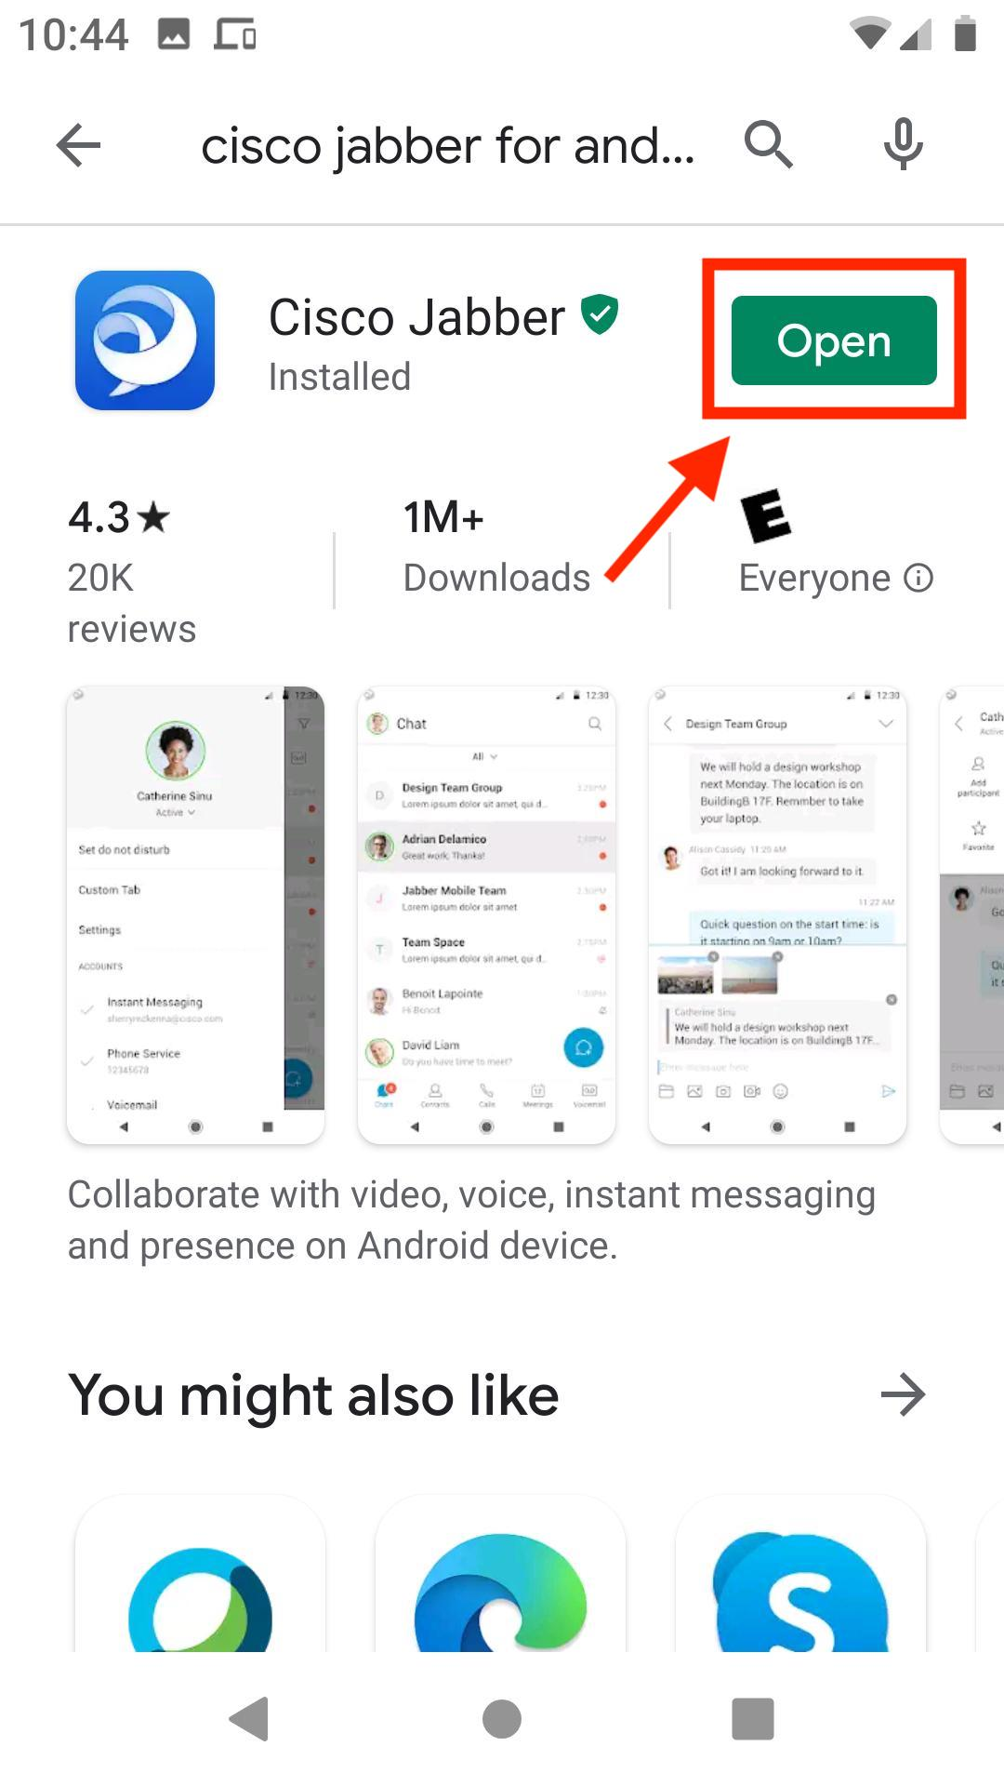

- Once the Jabber app is open, select “Accept” after reading the terms.
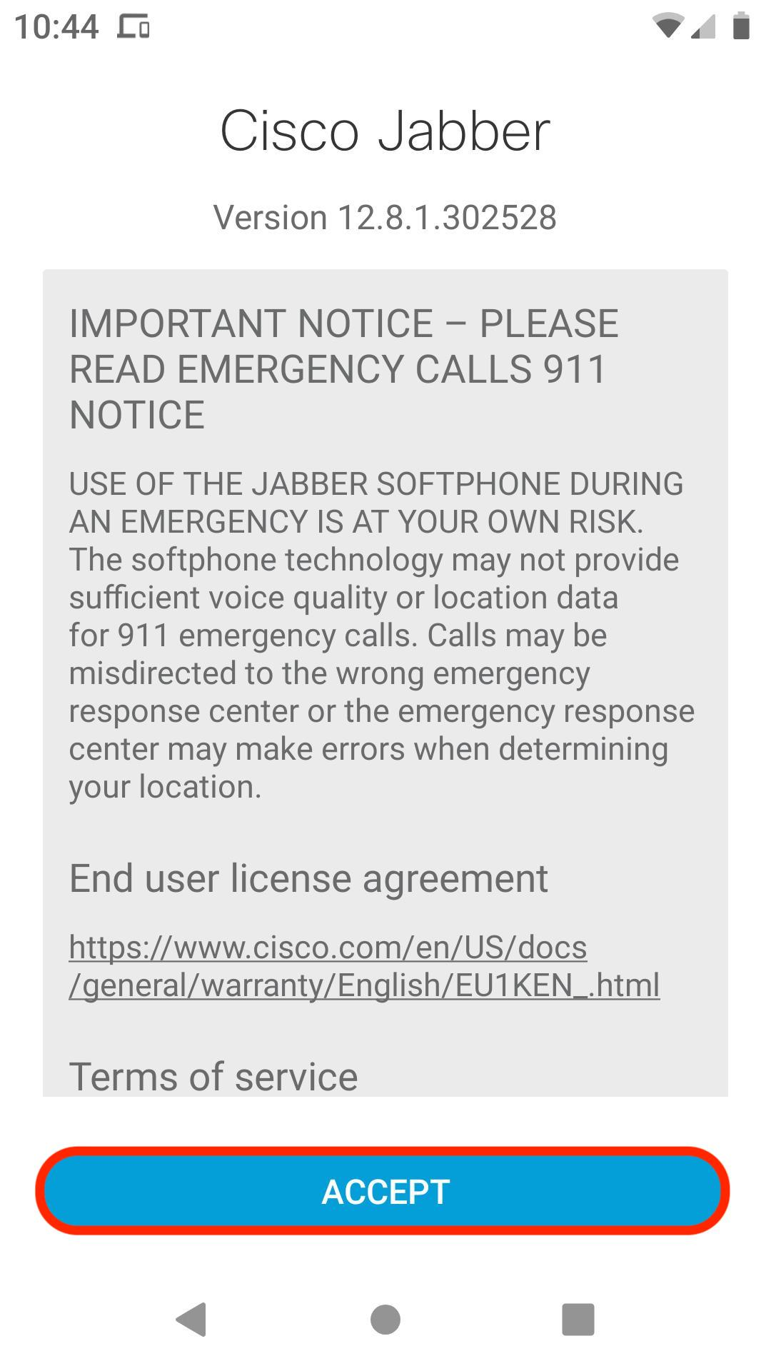

- Swipe through the next slides
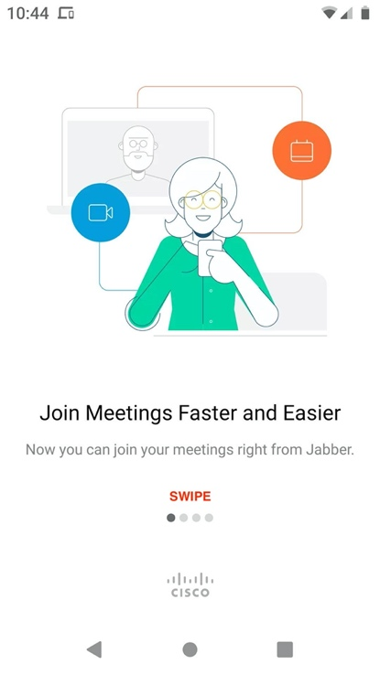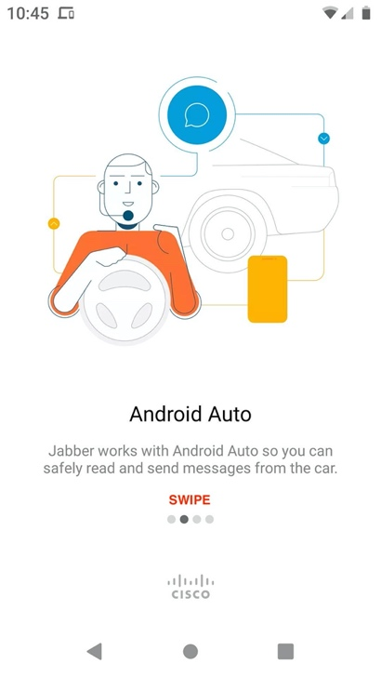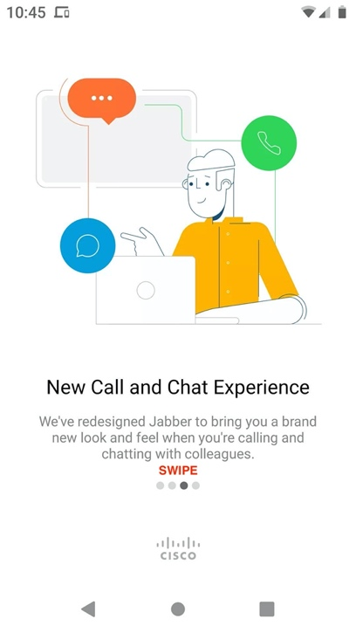

- Select “Get Started Now”
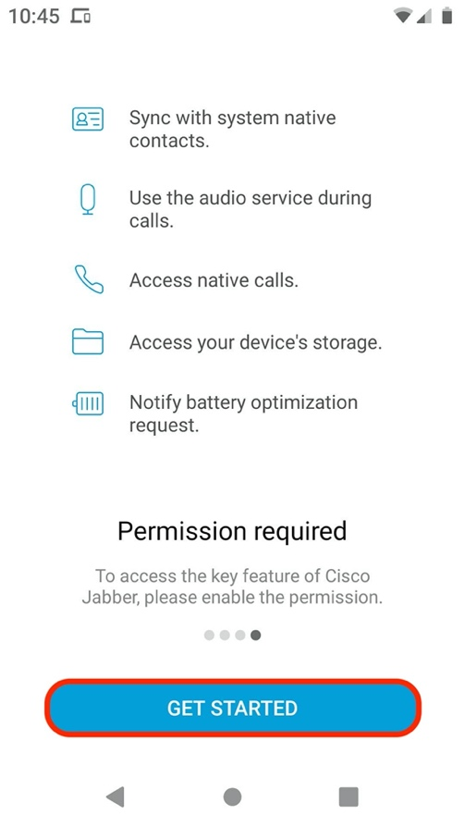
- Select “ALLOW”.
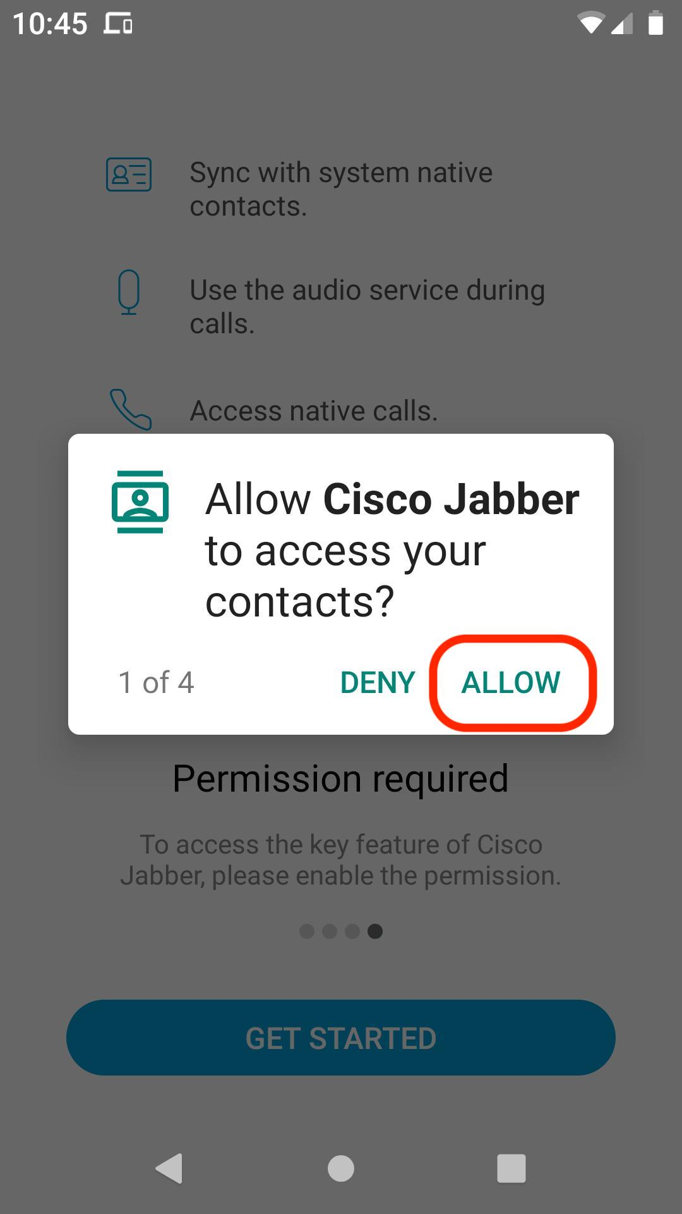

- Select “ALLOW”.
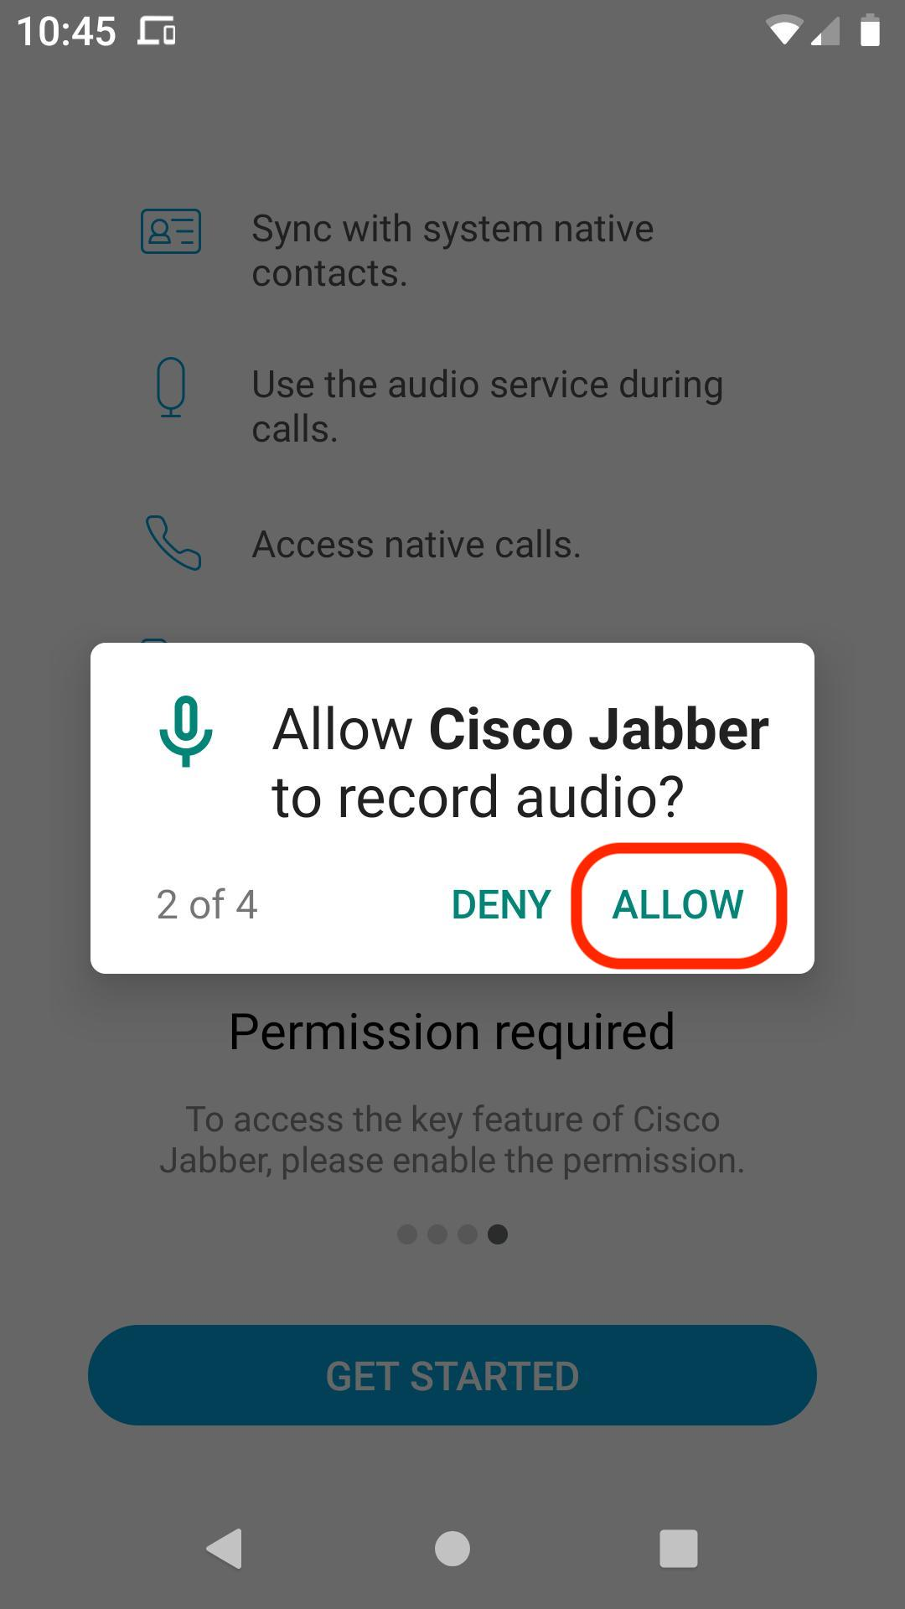

- Select “ALLOW”.
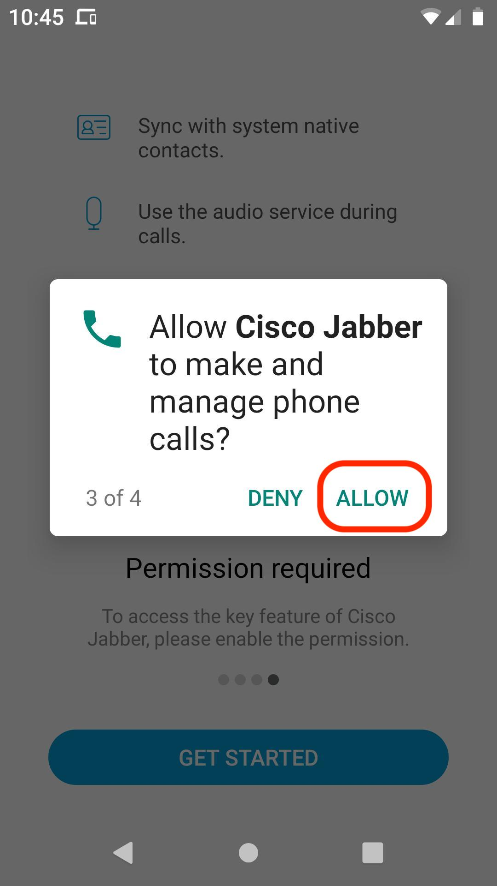
- Select “ALLOW”.
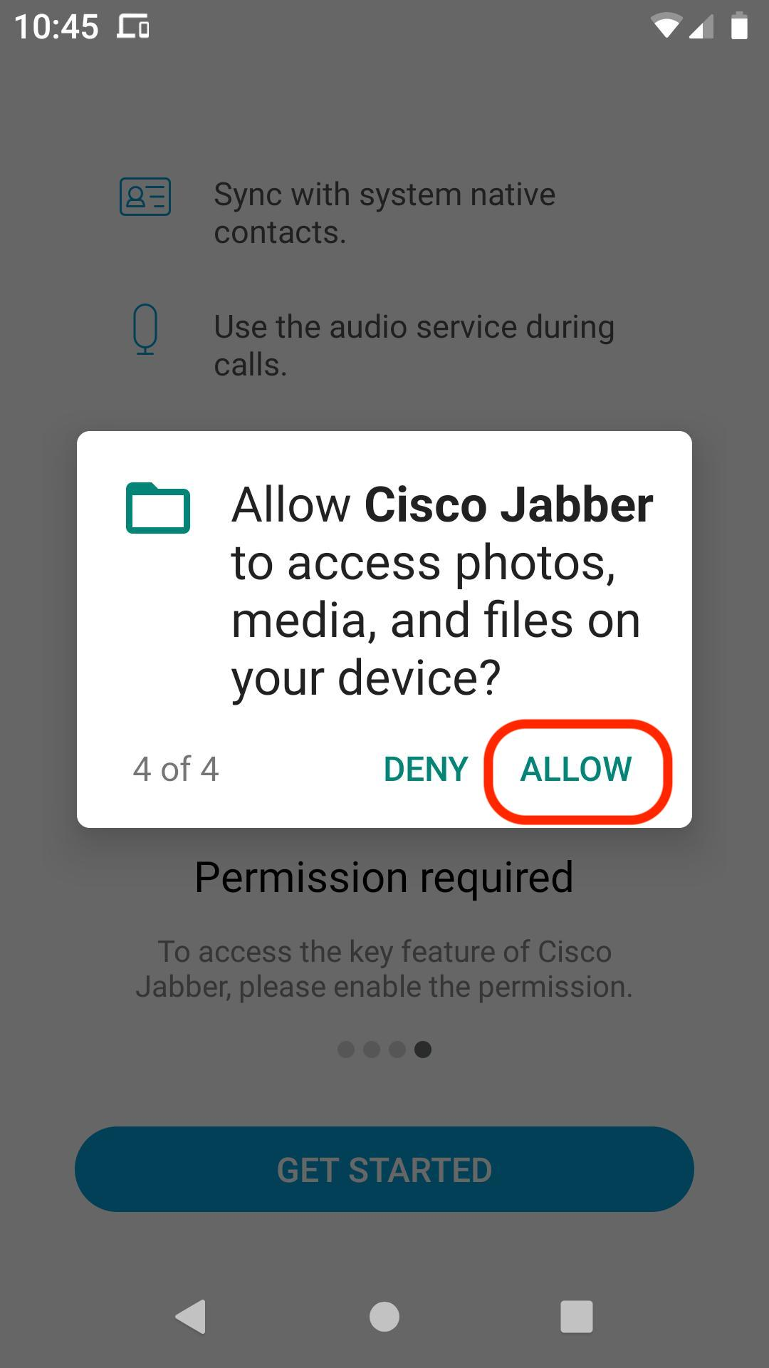
- Select “ALLOW”.
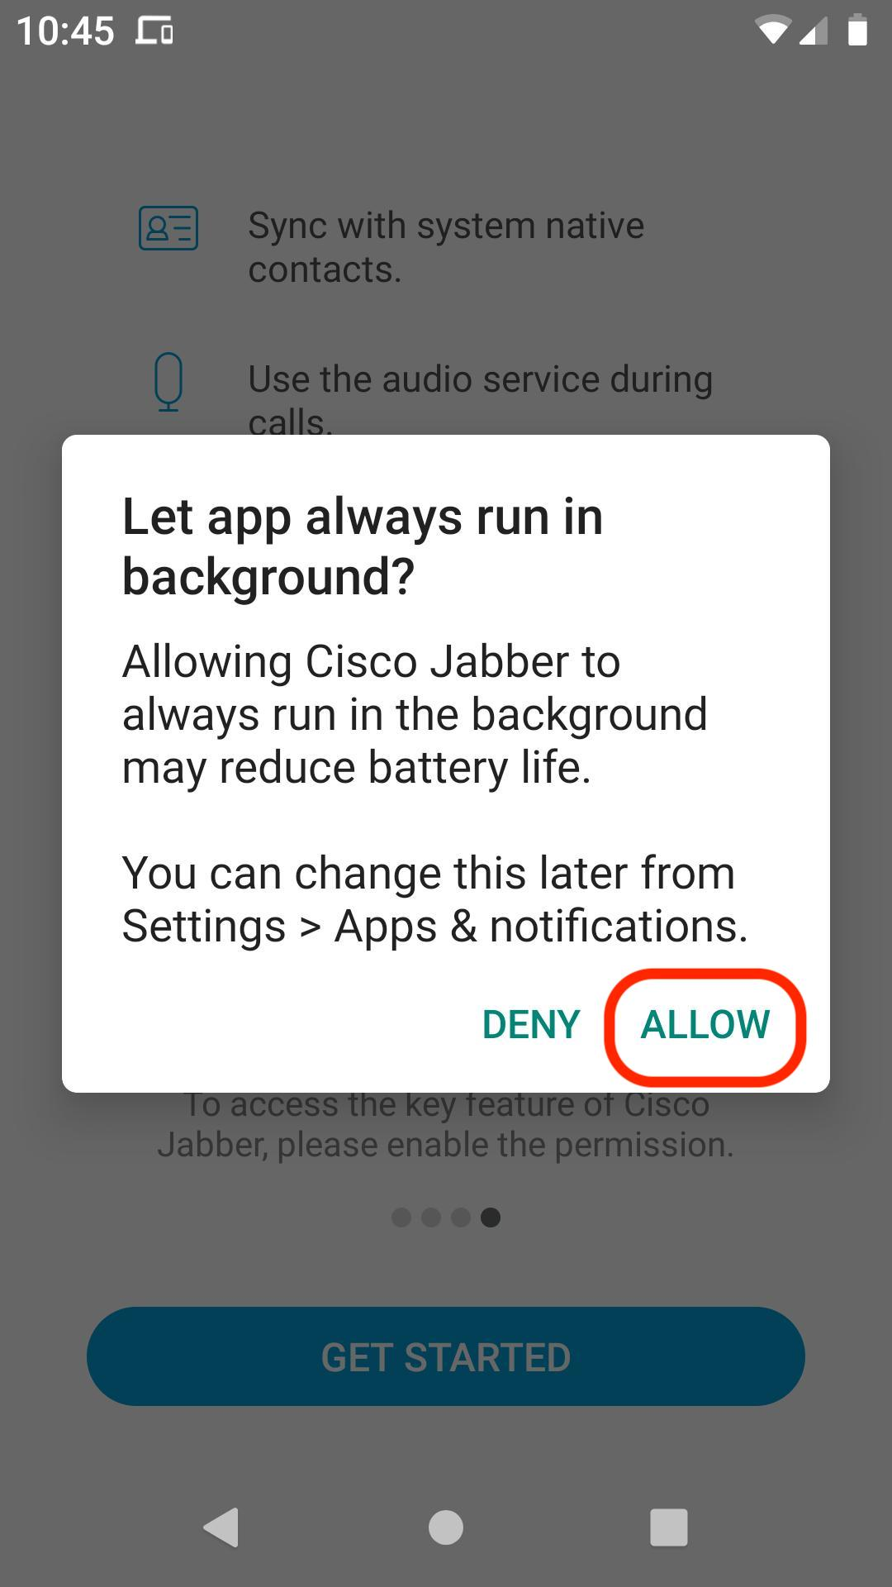
- Type in your NTNET (Tarleton) email then select “Continue”.
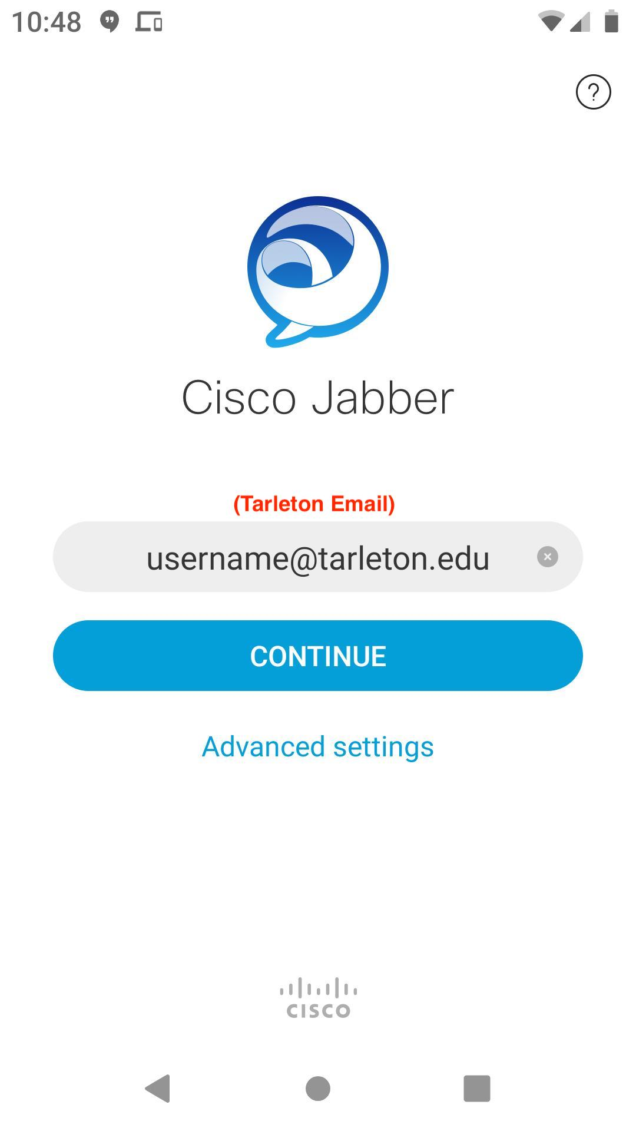

- Type in your NTNET (Tarleton) password then select “Sign In”.
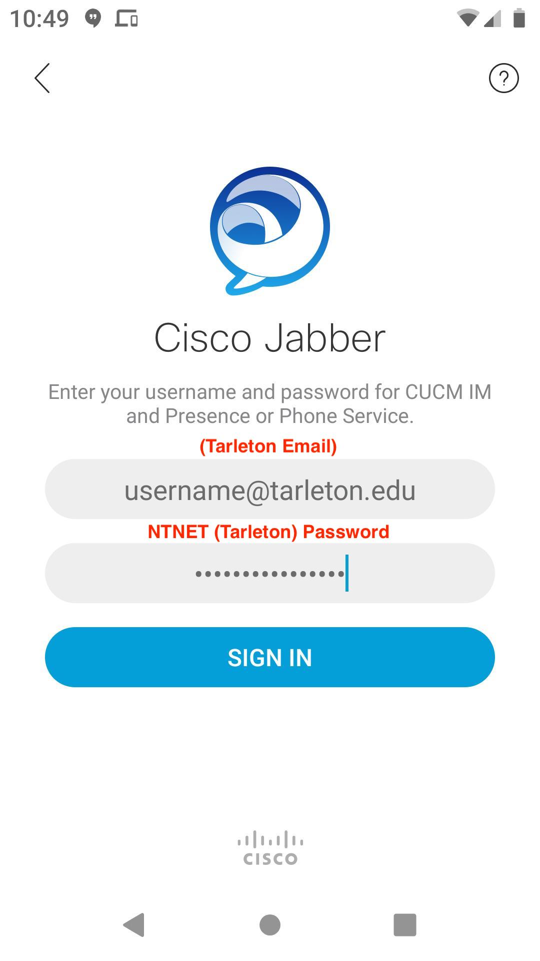

- This is optional and up to each user.
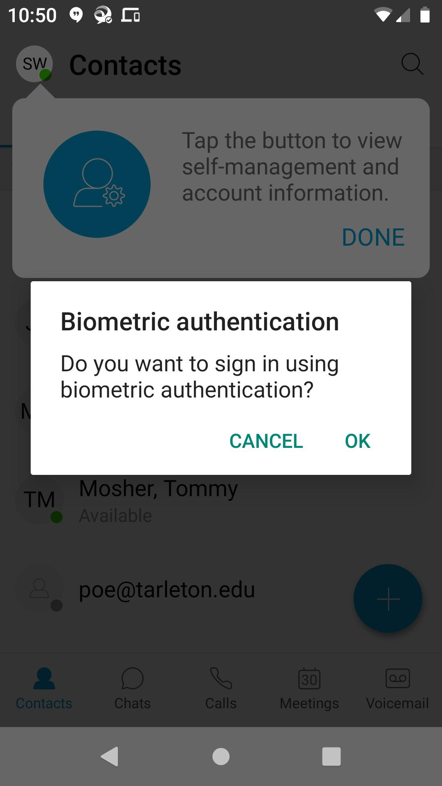

- Select “Done”.
